|  |  |
| --- | --- |
| **Project case – External Document** |  |
| COMP7084 | T0553  Multimedia Systems |
| *Odd Semester Year 2020/2021* |

* Project Title

Good Computer Shop

* Introduction

To create a multimedia project, which must have an attractive design and features, easy to use, informative, and interactive. Give information about the computer equipment (e.g. Keyboard, mouse, headset, etc). Make sure to create an attractive UI for the app, and don’t forget to provide the customer with how to buy a product on the website.

* Report / Documentation

1. 3 Pieces of Movie Clip

Layer that includes Movie Clips has been named <*layername*>MC. Each of the layer has one movie clip. There are more than 3 pieces of movie clips in the project.

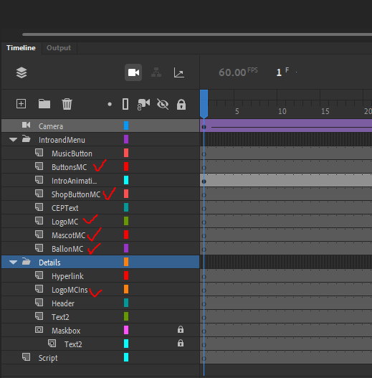

1. 2 Pieces of Button

There are more 8 buttons in main menu, and a back button for each of computer equipment (total of 6 buttons), and 2 buttons in how to shop page.

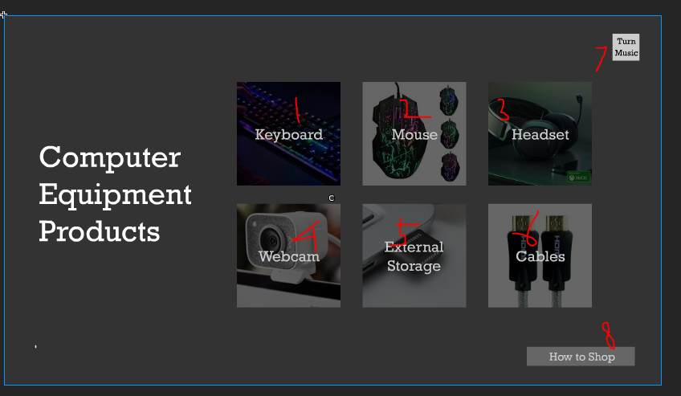

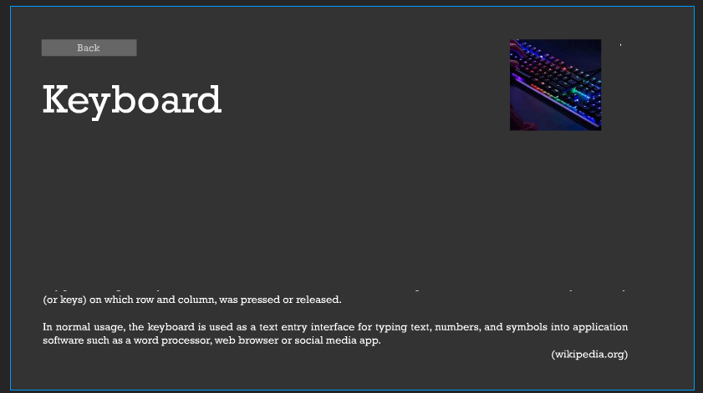

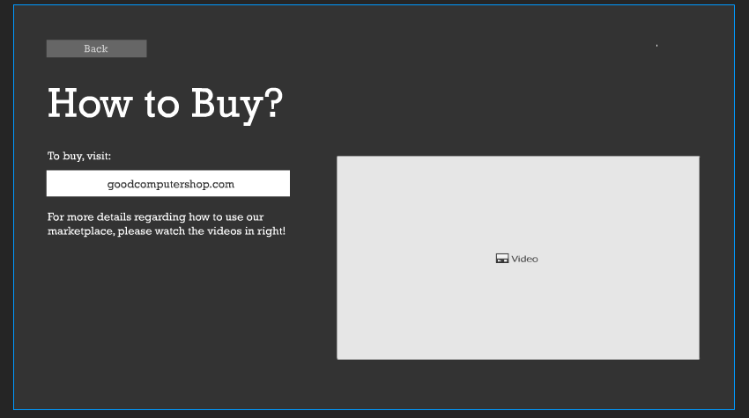

1. 2 pieces of motion or classic tween with different animations

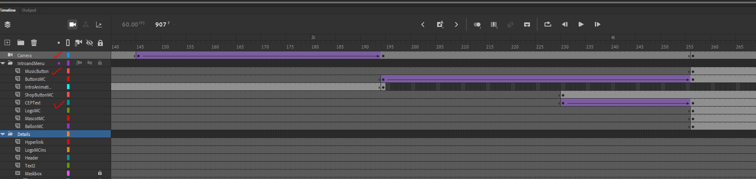

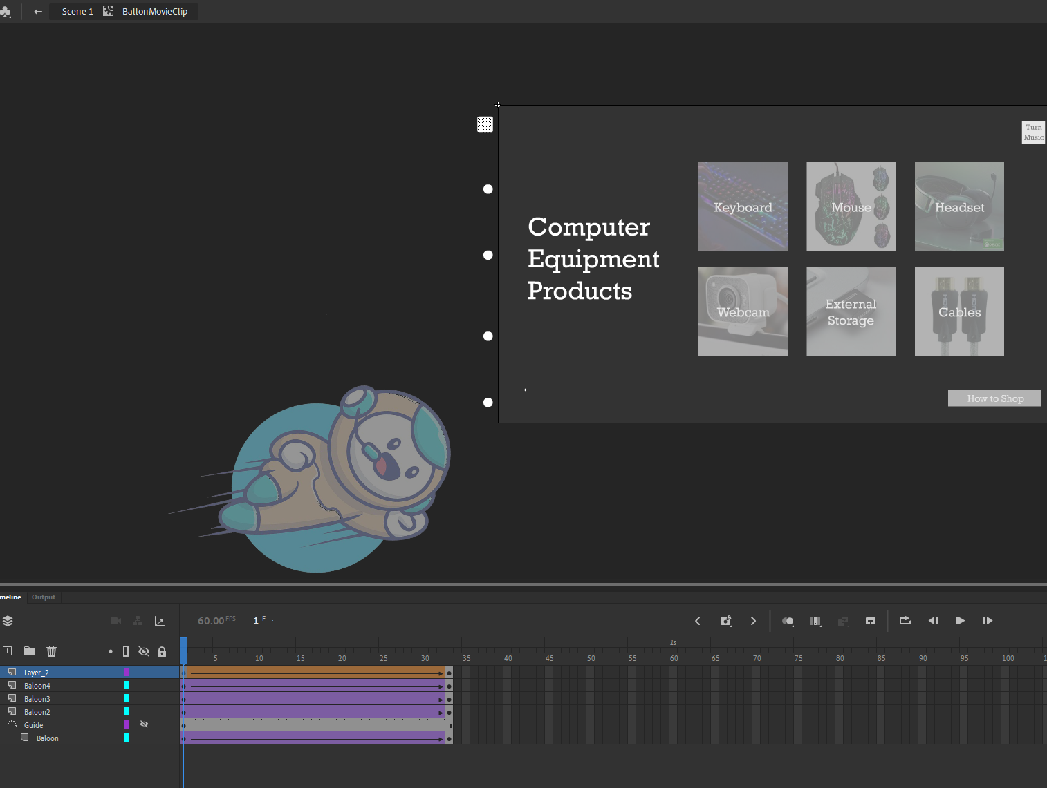

1. 2 pieces of shape tween with different animations



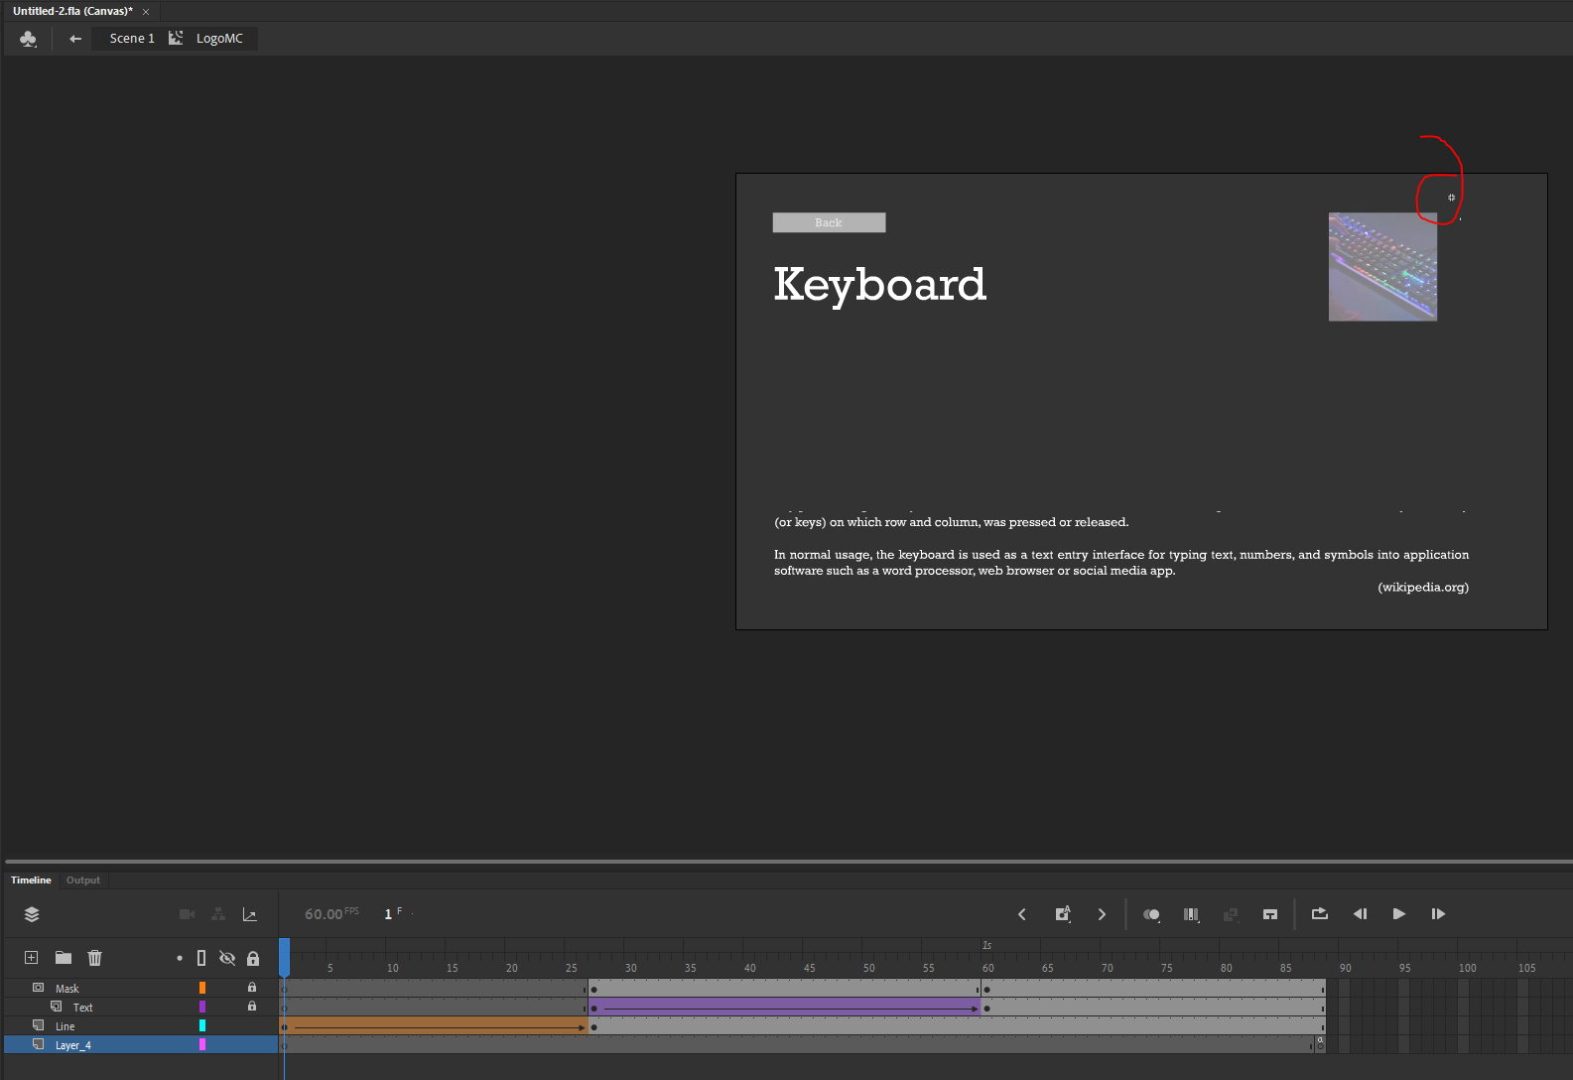

1. 2 pieces of masking

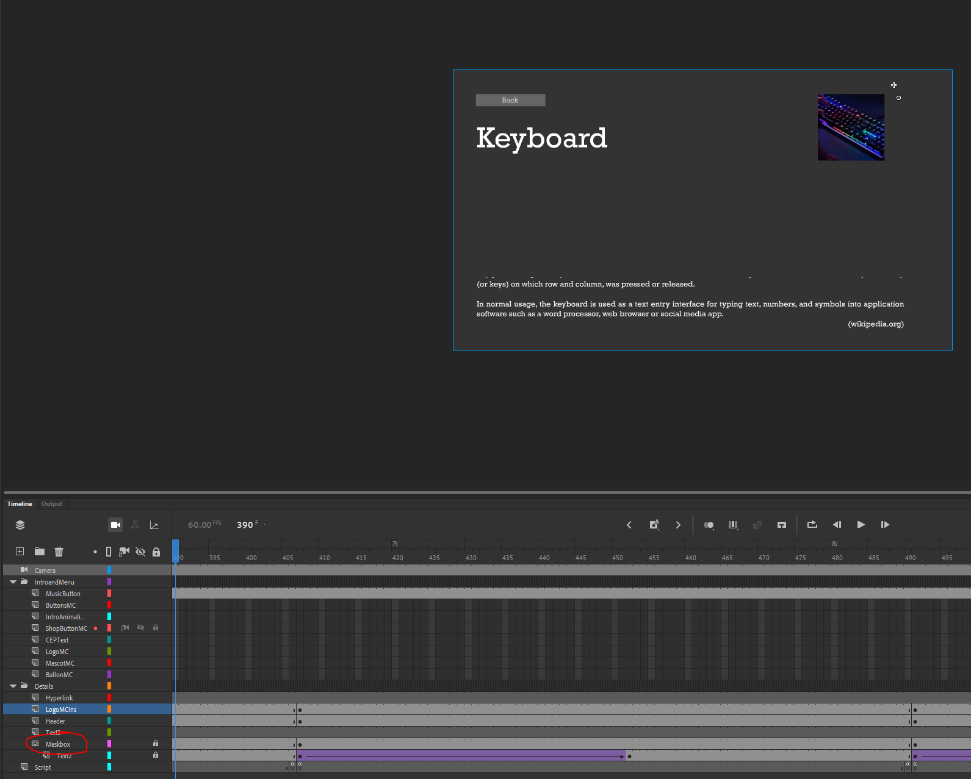

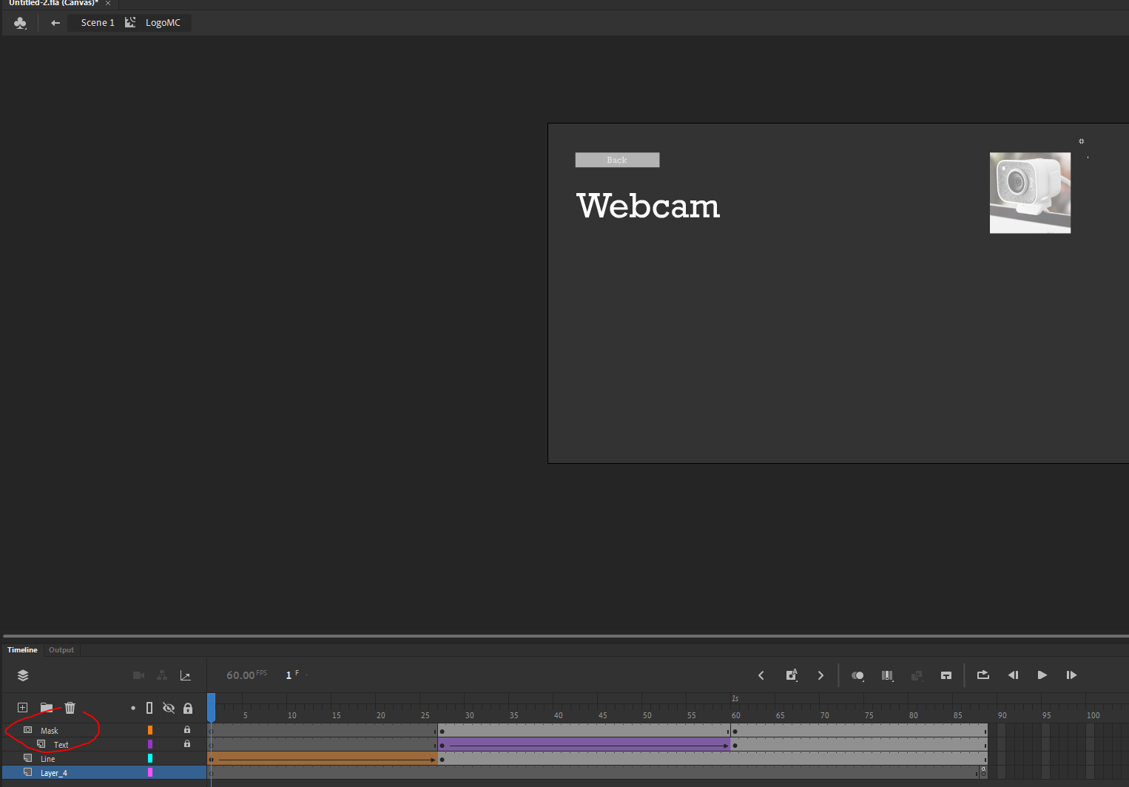

1. 2 pieces of guide with different animations

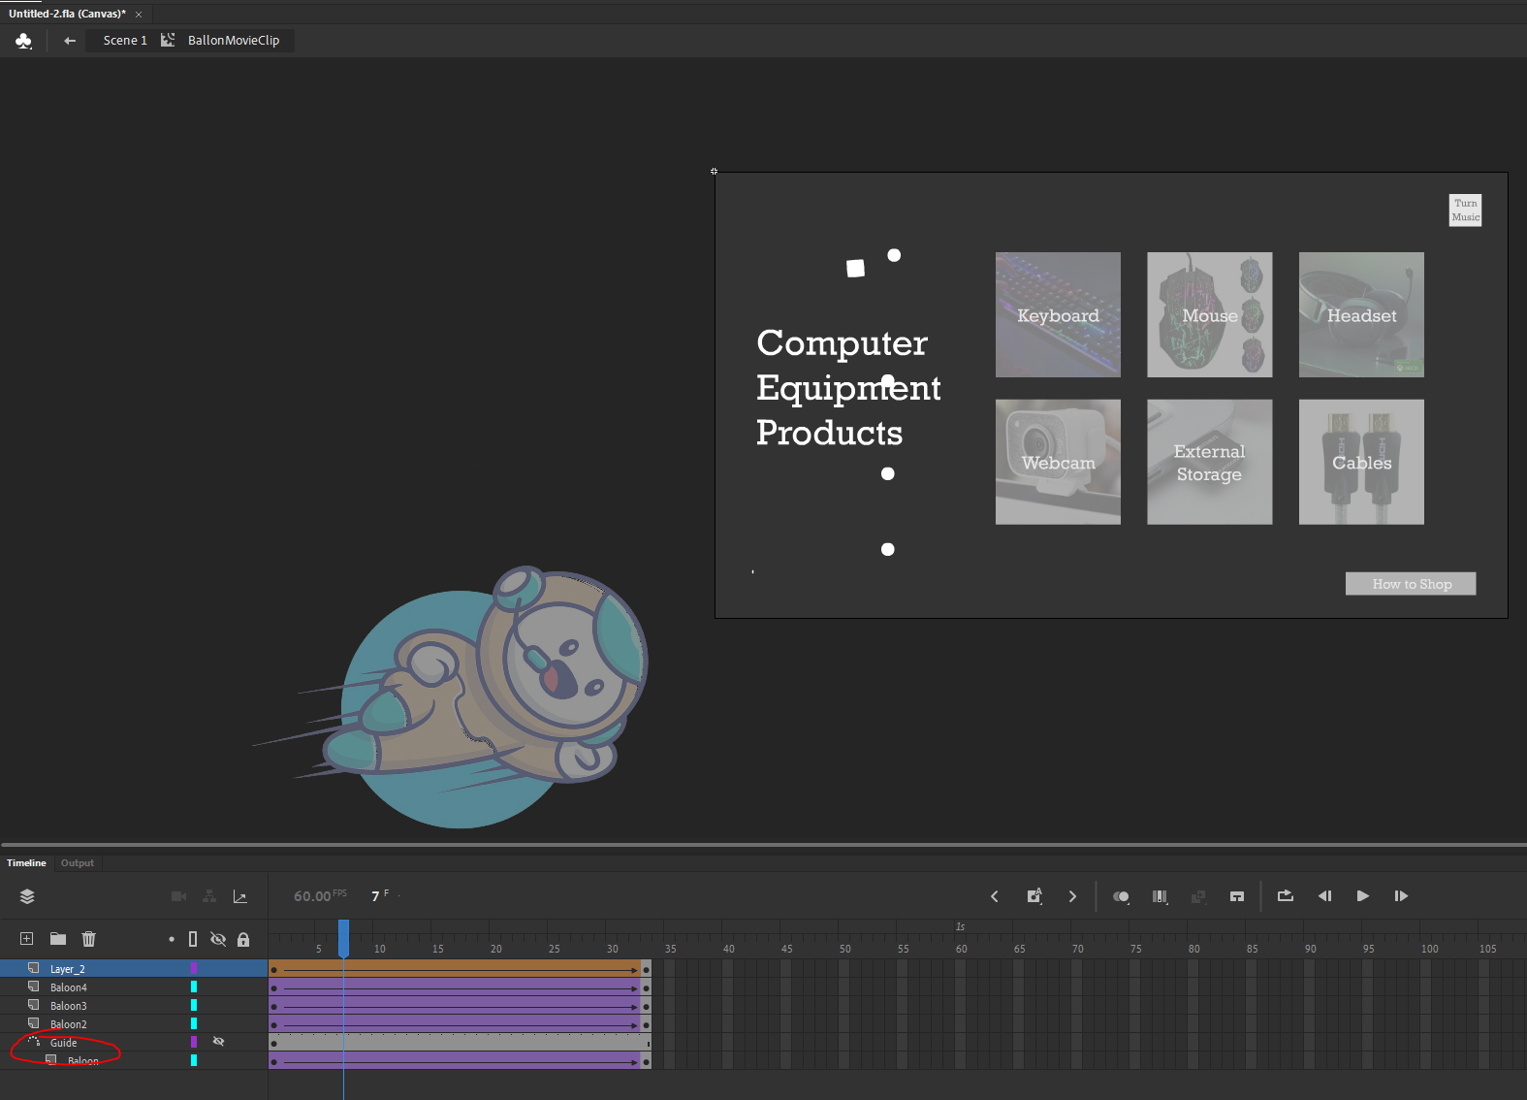

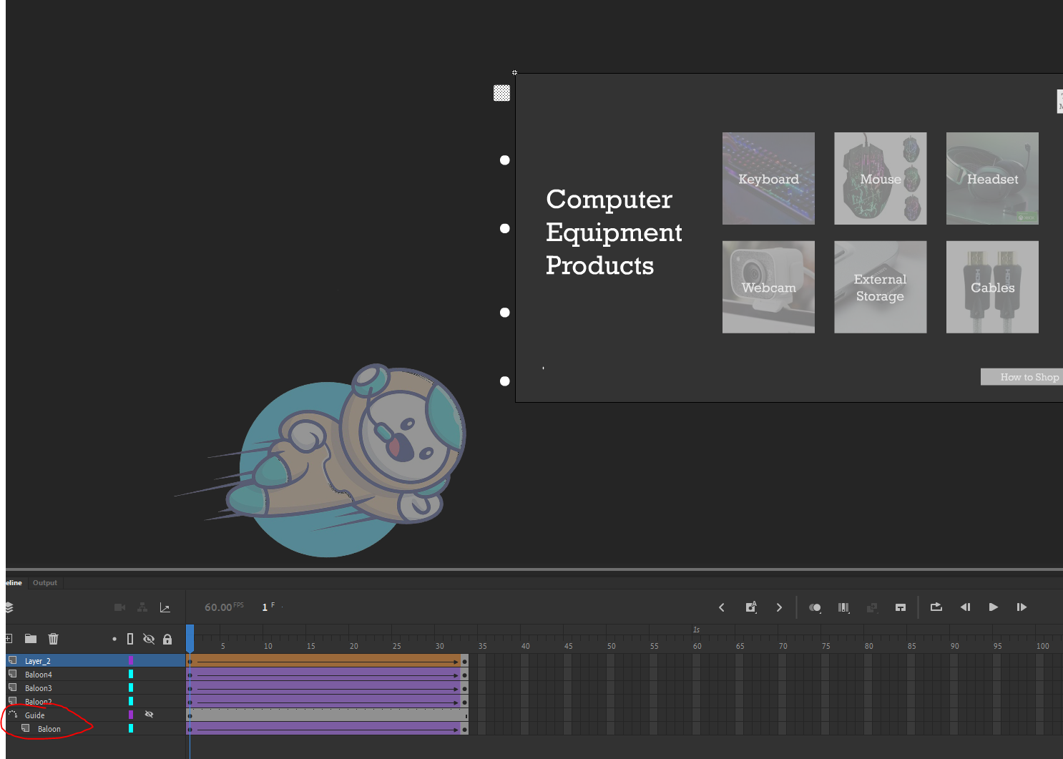

1. 2 kinds of event

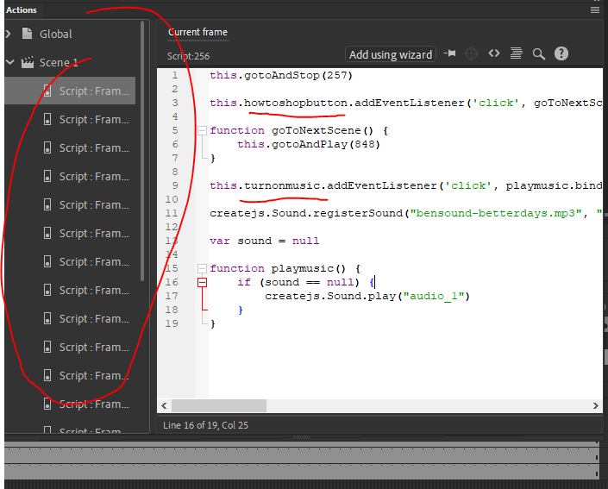

1. 3 kinds of frame control

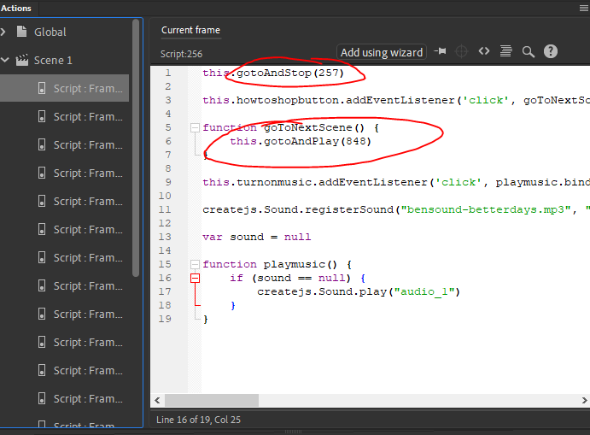

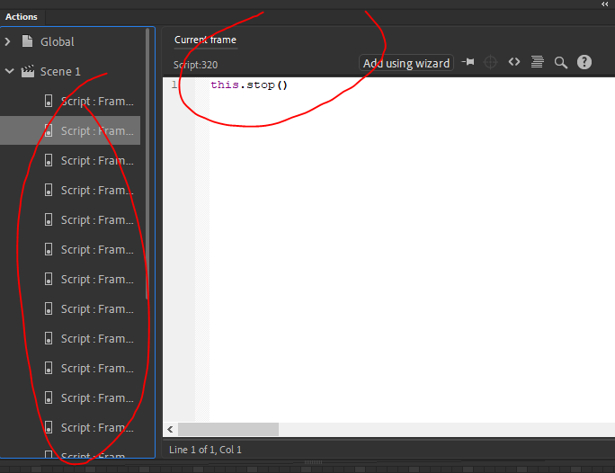

1. 1 video

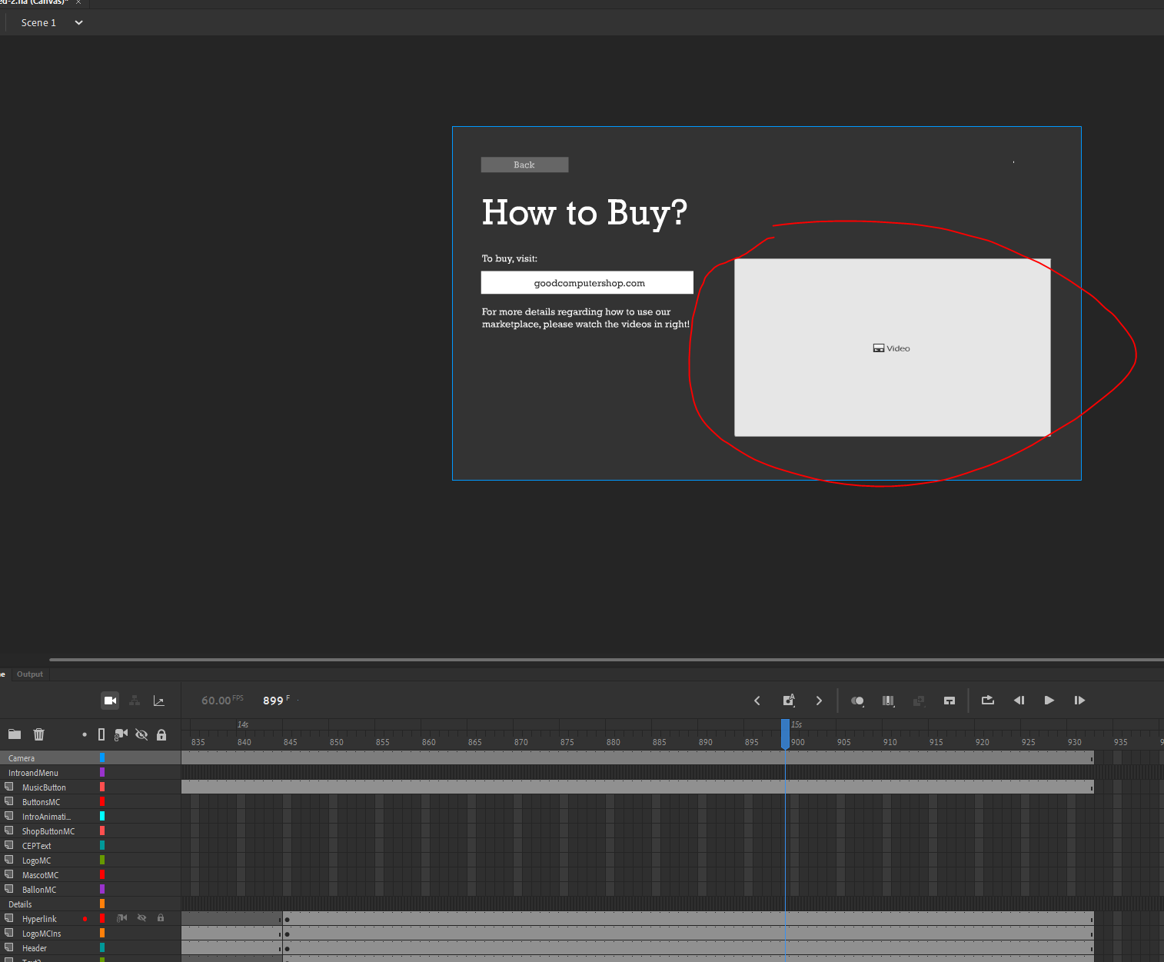

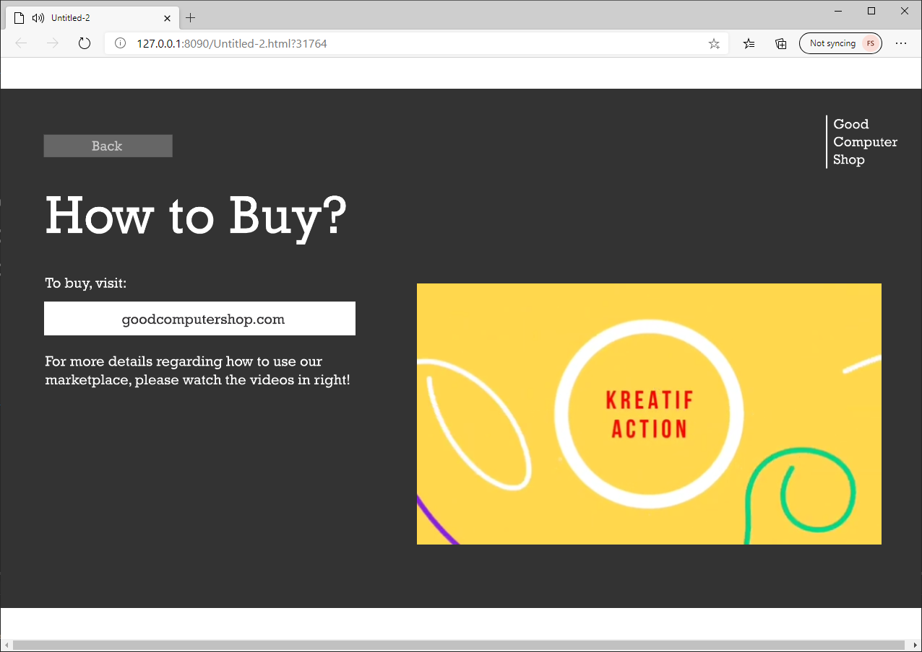

1. 1 audio

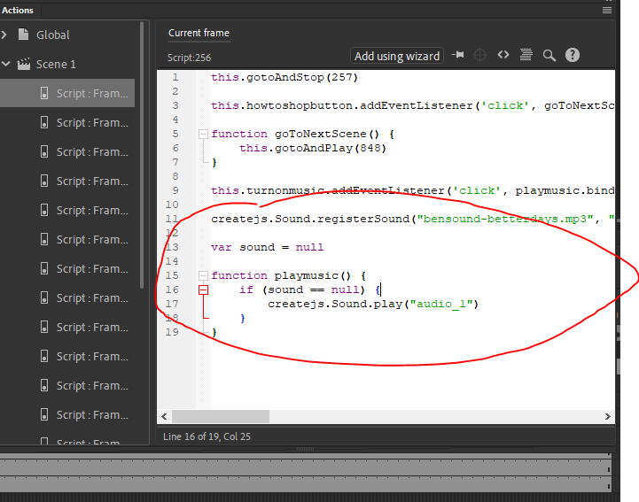

1. 1 virtual camera

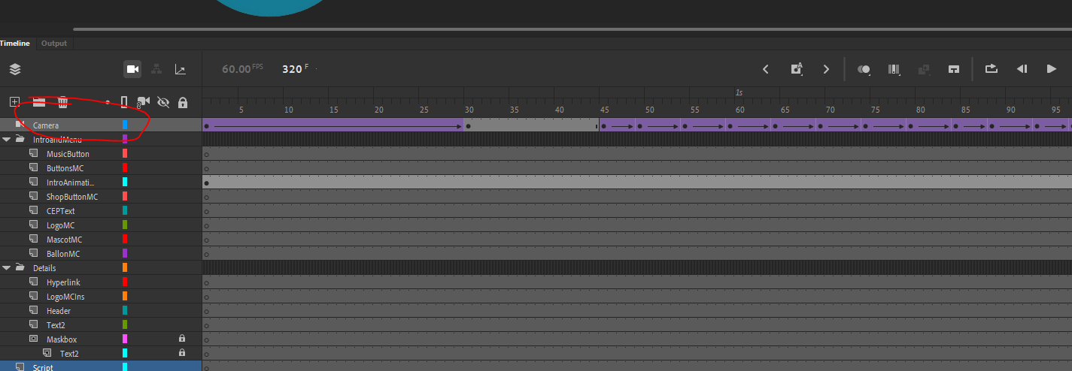

1. 1 hyperlink

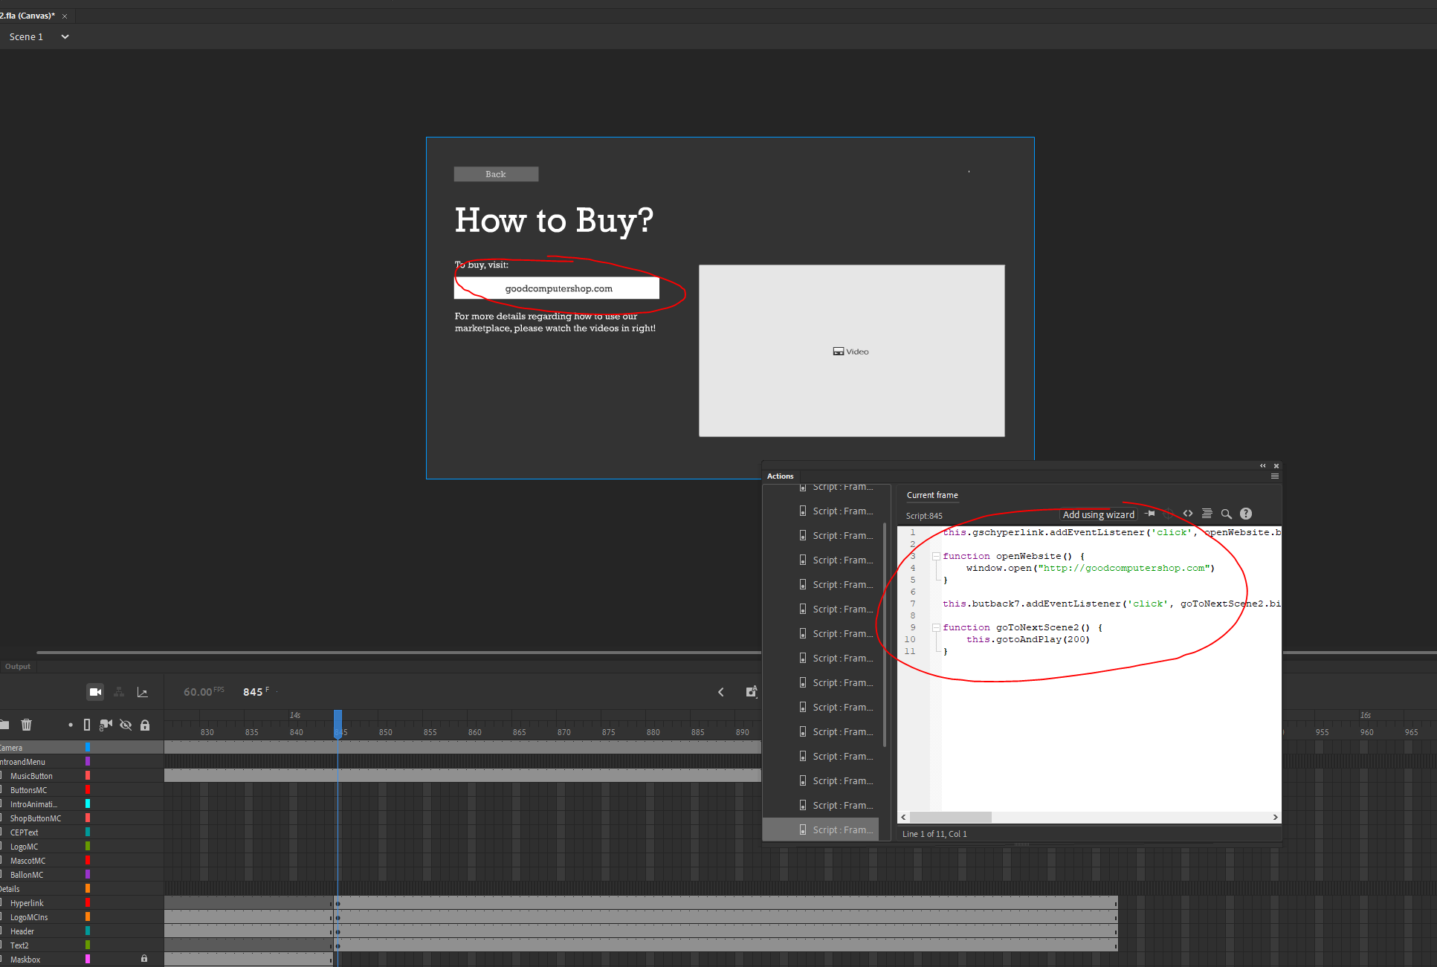

1. Hidden Creativities
2. Permainan kamera untuk intro

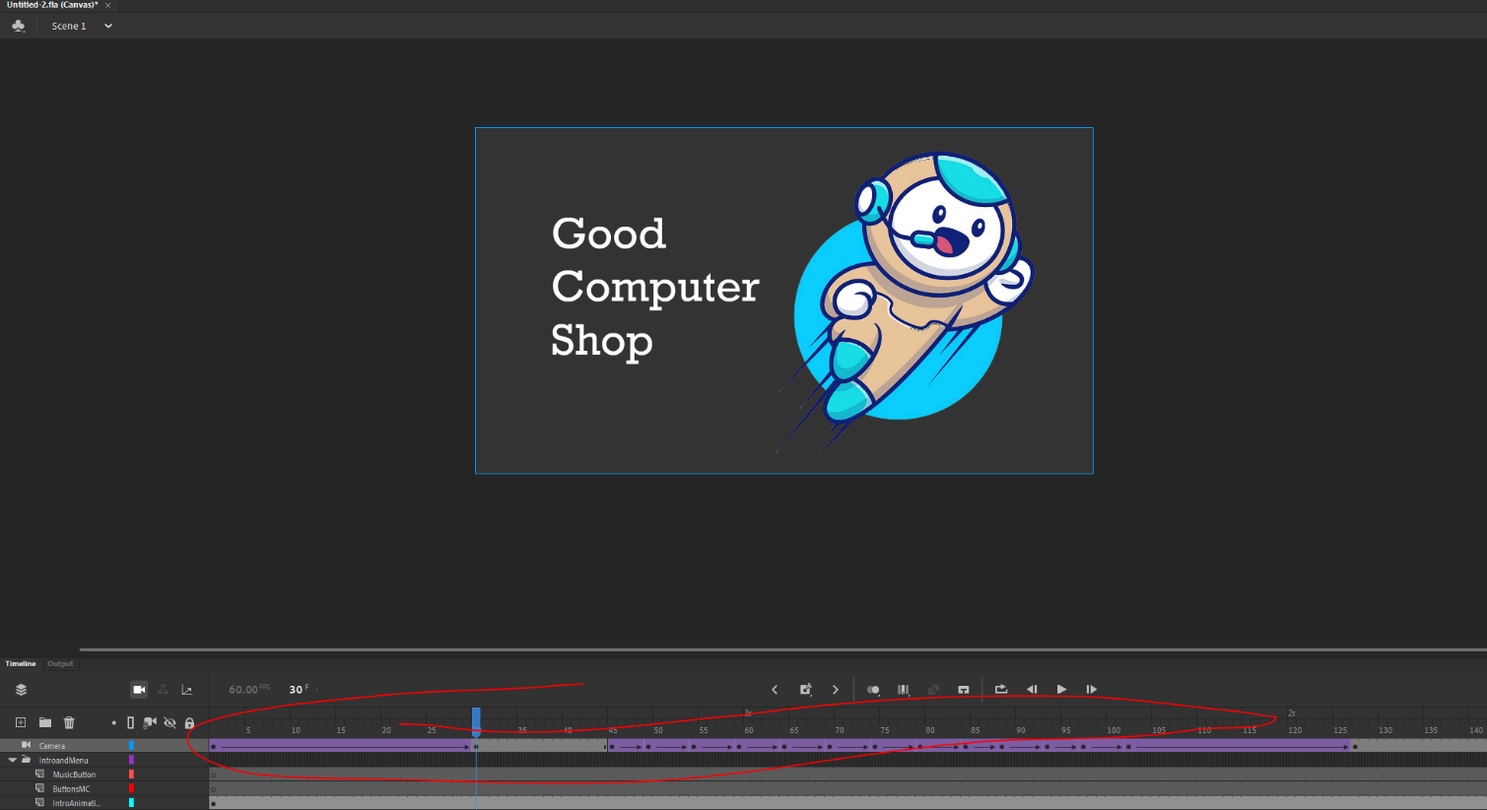

1. Permainan opacity dan gerakan ketika memasuki main menu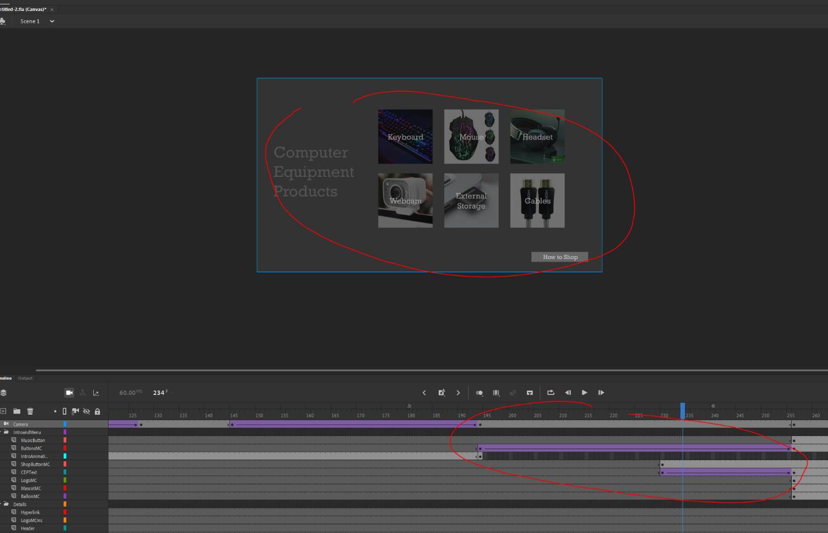

* Reference
* Mascot600px.png

Source: https://www.freepik.com/free-vector/cute-robot-flying-cartoon-illustration-people-technology-icon-concept_10244952.htm#page=1&query=mascot&position=5

Notes: Made transparent and resized to 600px x 600px in Adobe Photoshop CC

* Keyboard.jpg

Source: http://thetechnohaven.com/best-gaming-keyboards/

Notes: Cropped and resized to 170px x 170px in Adobe Photoshop CC

* Mouse.jpg

Source: https://www.wish.com/product/usb-wired-5500dpi-7-buttons-7-colors-led-optical-mouse-professional-gamer-mouse-computer-mouse-gaming-mouse-for-pc-computer-599833223eb22a5853418913?hide_login_modal=true&share=web

Notes: Resized to 170px x 170px in Adobe Photoshop CC

* Headset.jpg

Source: https://steelseries.com/gaming-headsets/arctis-9x

Notes: Resized to 170px x 170px in Adobe Photoshop CC

* Webcam.jpg

Source: https://www.laptopmag.com/articles/best-webcams

Notes: Resized to 170px x 170px in Adobe Photoshop CC

* External.jpg

Source: https://www.rollingstone.com/product-recommendations/electronics/best-flash-drives-994088/

Notes: Resized to 170px x 170px in Adobe Photoshop CC

* Cables.jpg

Source: https://www.lowes.com/pd/GE-12-ft-High-Speed-HDMI-Cable/1000329669

Notes: Resized to 170px x 170px in Adobe Photoshop CC

* carabelanja.mp4

Source: https://www.youtube.com/watch?v=CG2AIt2j_O8

* bensound-betterdays.mp3

Source: <https://www.bensound.com/royalty-free-music/track/better-days>

* Teks untuk penjelasan computer equipment

(sesuai permintaan soal “*Give information about the computer equipment (e.g. Keyboard, mouse, headset, etc)*”)

Sumber: wikipedia.org dan computerhope.com

* Group Member
* 2301857494 - Christ Anderson Wisnu
* 2301866555 - Claudio Yonatan
* 2301870110 - Kathleen Febiola Susanto
* 2301905556 - Franky Setiawan